**OpenFDA- D-Health App**

Ophthalmic Device 510(k) clearances analysis:

Total number of devices: 4253

After analyzing the number of 510(k) applications by date received and decision data, the results look like following:

**510(k) applications by decision date:**

api call: <https://api.fda.gov/device/510k.json?search=medical_specialty_description:ophthalmic&count=decision_date>

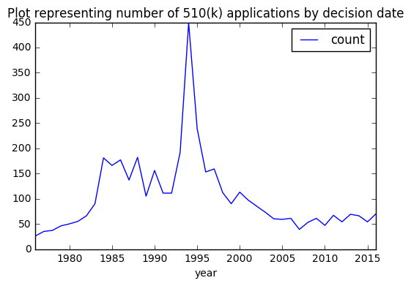

**510(k) applications by date received**

**api call:** <https://api.fda.gov/device/510k.json?search=medical_specialty_description:ophthalmic&count=date_recieved>

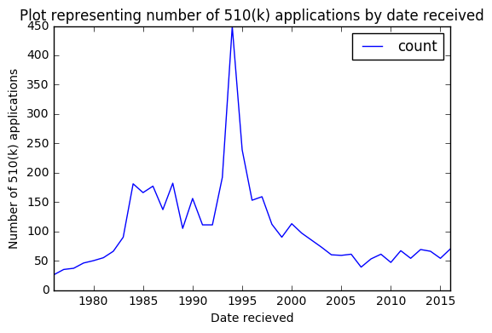

**Number of 510(k) applications by state:**

**Api call:** <https://api.fda.gov/device/510k.json?search=medical_specialty_description:ophthalmic&count=state>

